**Malaysian Abstraction**

Malaysian abstract artists of the 1960s were an eclectic group, drawing mainly on stylistic idioms ranging from Cubism, Expressionism, English landscape abstraction and later American Abstract Expressionism. Their overseas training introduced them to European and American mainstream art of that period, and their anti-naturalistic idiom was a departure from the watercolor tradition introduced by British expatriates and the Shanghai school of Post-Impressionism and Cubism from the Nanyang Academy of Fine Art in Singapore. The internationalist and cosmopolitan affectation of these Kuala Lumpur based abstract artists belied a keen exploration of local subjects and concerns. These include the incorporation of jawi calligraphy and pattern in Syed Ahmad Jamal’s *Tulisan* (1961); paddy field landscape in Yeoh Jin Leng’s *Sawah Padi* (1963); and Latiff Mohidin’s search for a regional motif in his *Pago-pago* series. The personal associations and commitment towards exploring highly individualised modes of expression culminated in an exhibition titled GRUP in 1967. The event would mark the arrival of abstraction as a force to be reckoned with. In the following year, their show of strength would antagonise members of Angkatan Pelukis Se-Malaysia (APS), who staged a protest and walk out from the Salon Malaysia exhibition following a perceived slight that the competition favoured abstraction over realism.

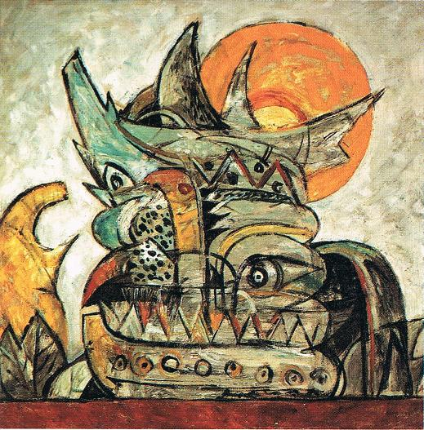

Abdul Latiff Mohidin, *Pago-Pago*, 1964, oil on canvas, 100 x 100.3 cm, Malaysian National Art Gallery Collection.

<http://oil-painting-mezan.blogspot.ca/2010/11/oil-painting-artwork.html>

In 1969, a younger group of abstract artists emerged. Unlike the 1960s generation who worked individually without any movement or ideology, artists connected to the 1969 *The New Scene* exhibition championed hard-edge abstraction as a cerebral and analytical form of art practice against what they perceived to be the emotive and gestural inclination of 1960s abstraction. These practitioners understood Malaysian abstract art as a suitable and cogent artistic vernacular to articulate both national and global character. As Syed Ahmad Jamal notes, “Malaysian artists were not looking back to history. There were no national archetypes to relate to. The art scene was devoid of any awareness as historical stepping-stones… tradition was being created then and there… The by-word was Malaysian Art starts now.”

For the foreign trained abstract artists, their facility with English and connections set them apart from the largely Malay-speaking Angkatan Pelukis Se-Malaysia. In fact, throughout the 1960s, abstract pioneers came to represent a new artistic ethos. In *The Disbanded GRUP – Houses, Myths and Art (1997),* exhibition curator Wong Hoy Cheong elucidates the aura which Malaysia’s first generation of modernists were able to construct around themselves, highlighting the mythical quality that pervaded the modernist artifice with the following observation, “This myth, functions as an idealised frame for artists and art students to negotiate with and aspire to.”

What interested Hoy Cheong are the images that accumulated around the pre-eminence of these artists’ stature. On the one hand, the large houses they lived in represented respectability and worldly success. On the other hand, they also projected the artistic life as imbued with mystique and privileged access to creative insight. The above instances, Hoy Cheong concludes “serve as frameworks and entry-points for the Malaysian art community and public. The development and direction of art, even today, is founded on negotiations with and through their art, thoughts and lifestyle.”

**References and further reading**

Sabapathy. T.K. (1994) ‘ Merdeka Makes Art, or Does It?’, *Vision and Idea: Relooking Modern Malaysian Art*, Kuala Lumpur: National Art Gallery.

Sabapathy, T.K. and Piyadasa Redza. (1983) *Modern Artists of Malaysia*, Dewan Bahasa dan Pustaka.

Shahir, Safrizal. (2012) ‘Abstract Themes and Approaches in Malaysian Modern Art’, *Narratives in Malaysian Art, Vol. I*, Kuala Lumpur: RogueArt, 2012.

Syed Ahmad Jamal,. (1987) ‘Malaysian Art 57 – 87’, *Seni Lukis Malaysia 57-87*, Kuala Lumpur: National Art Gallery.

Wong Hoy Cheong. (1997) ‘The Disbanded GRUP – Houses, Myths and Art’, *reGRUP: 30 Years On*, Kuala Lumpur: Valentine Willie Fine Art.